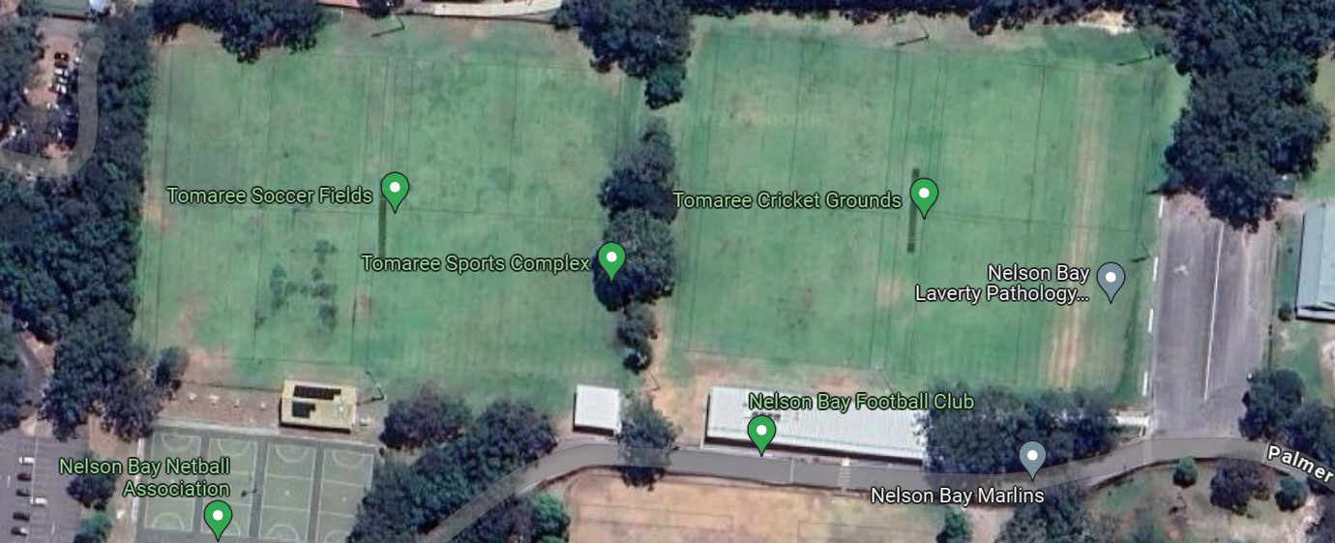
Meeting room
Field 3
Field 4
Field 2
Field 1

- There is parking around the grounds and over in front of the aquatic centre.
- Meeting room will be open of us to have meeting before the start of the day and at our breaks.
- Toilets are outside the meeting room complex.
- Zone might be best to set up in front of the meeting room and walk down to the fields that they are playing on.
- Orange areas for parents viewing- keeping them out of the middle of the ground.

